Composite materials

Project Report on Composite Materials
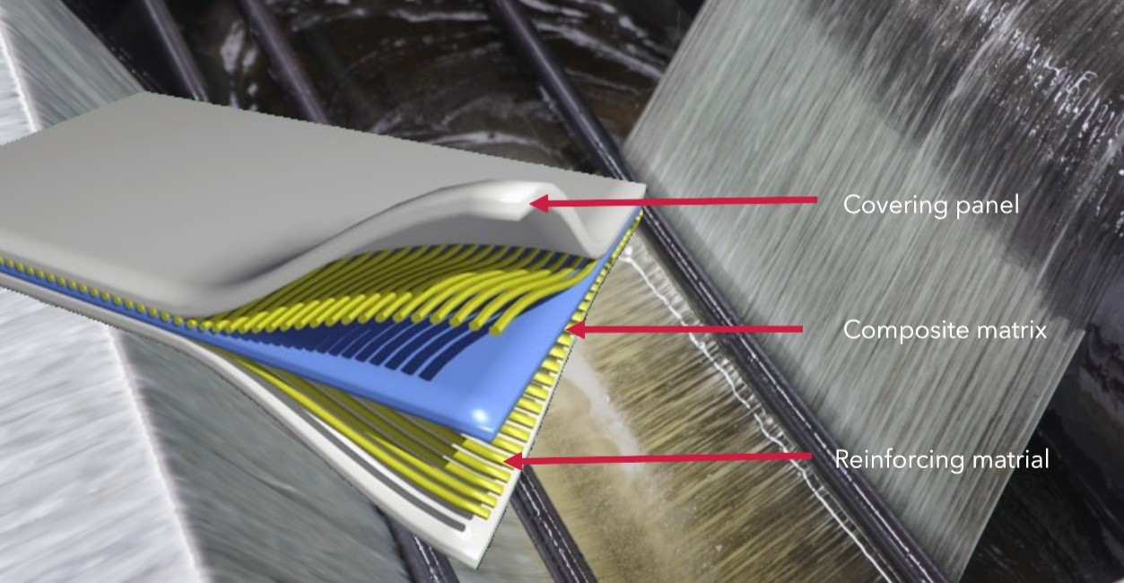

1. Introduction

Composite materials are engineered materials formed by combining two or more distinct constituent materials with significantly different physical or chemical properties. When combined, these materials produce a new material with characteristics superior to those of the individual components. This synergistic effect allows for the tailoring of properties such as strength, stiffness, weight, and corrosion resistance to meet specific design requirements.

1.1 Definition and Components
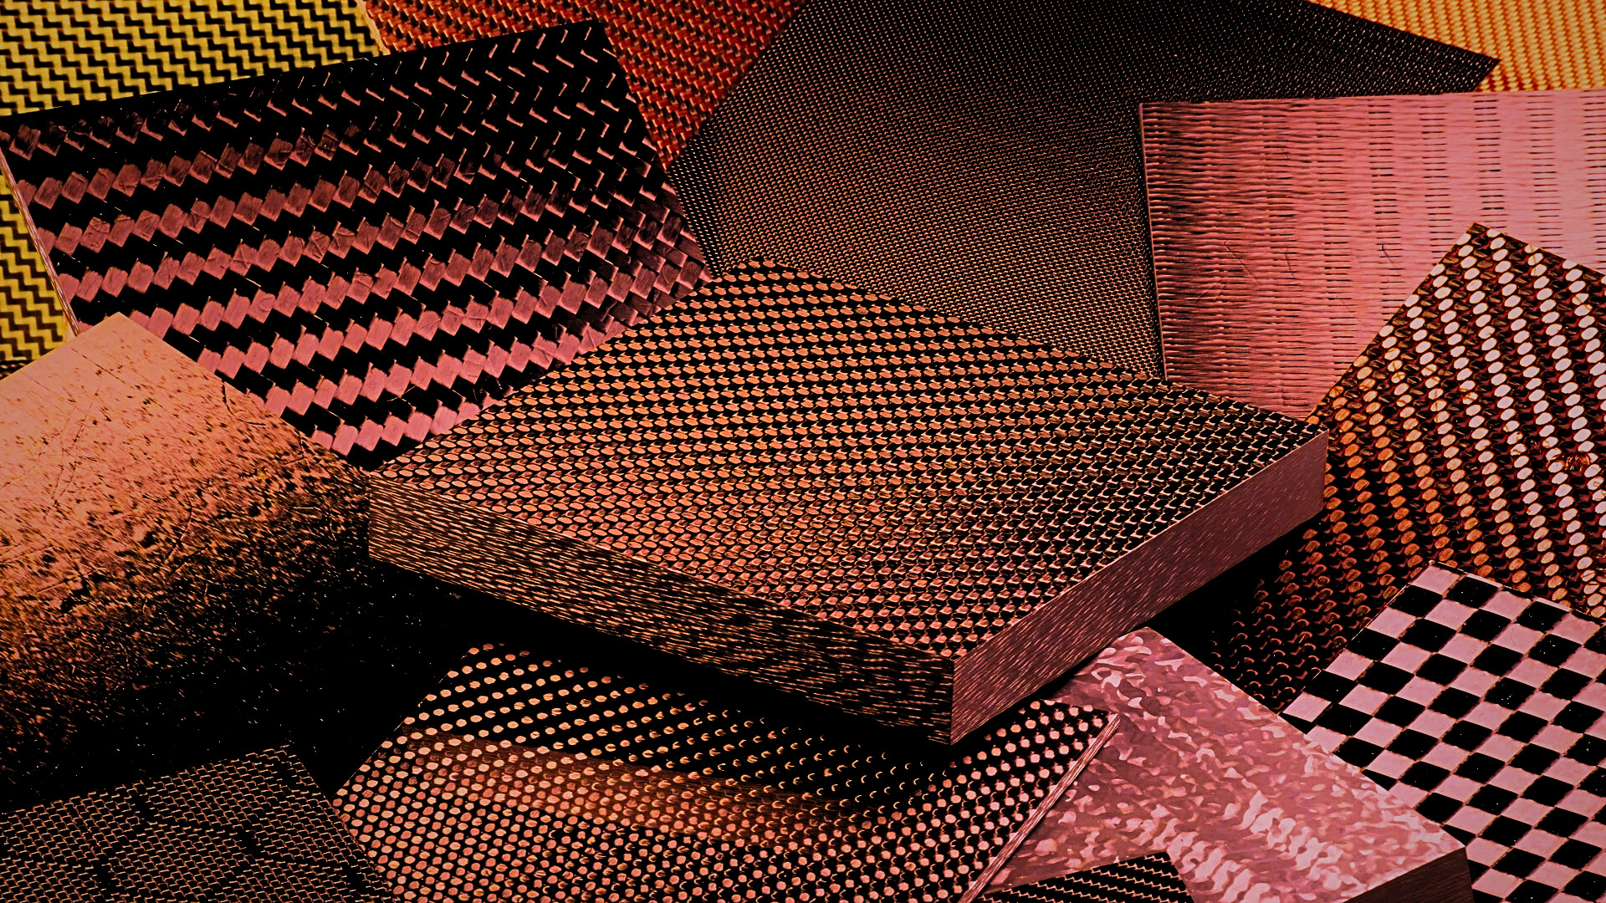

1. Matrix Phase: The continuous phase that surrounds and binds the reinforcement. It protects the reinforcement from environmental degradation and abrasion, and primarily serves to transfer the load between the reinforcement elements. Common matrices include polymers (epoxy, polyester), metals (aluminum, titanium), and ceramics.
2. Reinforcement Phase: The dispersed phase, usually stronger and stiffer than the matrix. It provides the primary load-bearing capability and determines the mechanical properties of the composite. Reinforcements are typically fibers (carbon, glass, aramid) or particulates.

2. History
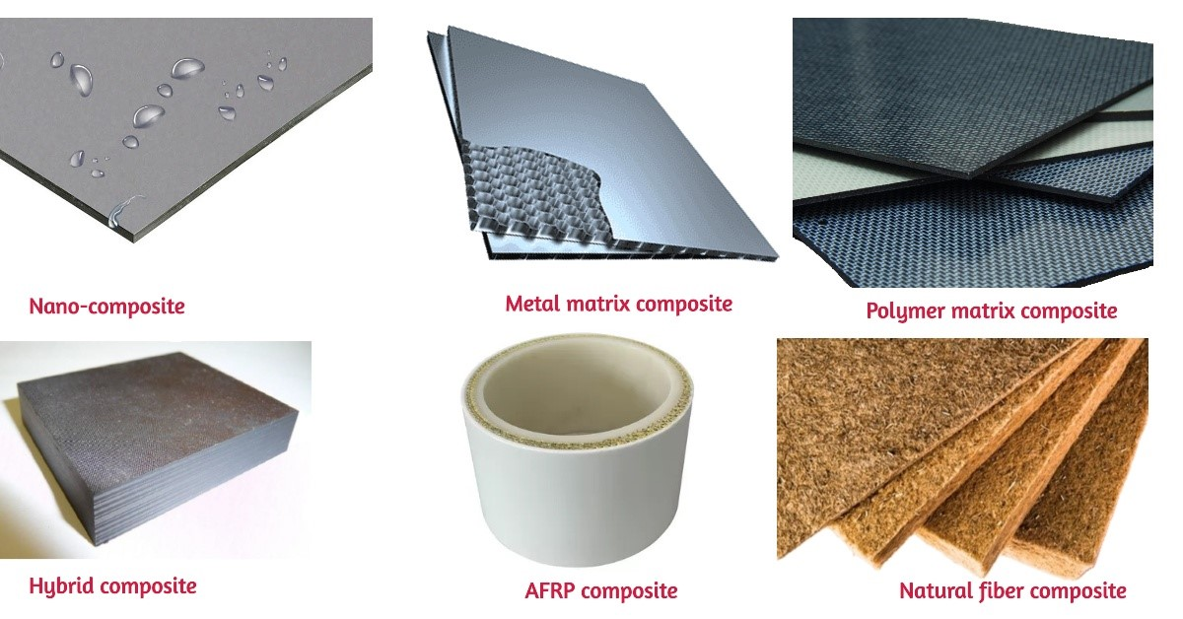
The use of composite materials is not a modern invention; the concept dates back thousands of years, evolving significantly with technological advancements.

2.1 Ancient Origins

Early examples of composites include ancient civilizations using mud bricks reinforced with straw (circa 3000 BC) to improve tensile strength and prevent cracking. Similarly, the ancient Egyptians utilized laminated wood structures (plywood concept) to achieve greater stability and durability than monolithic wood.
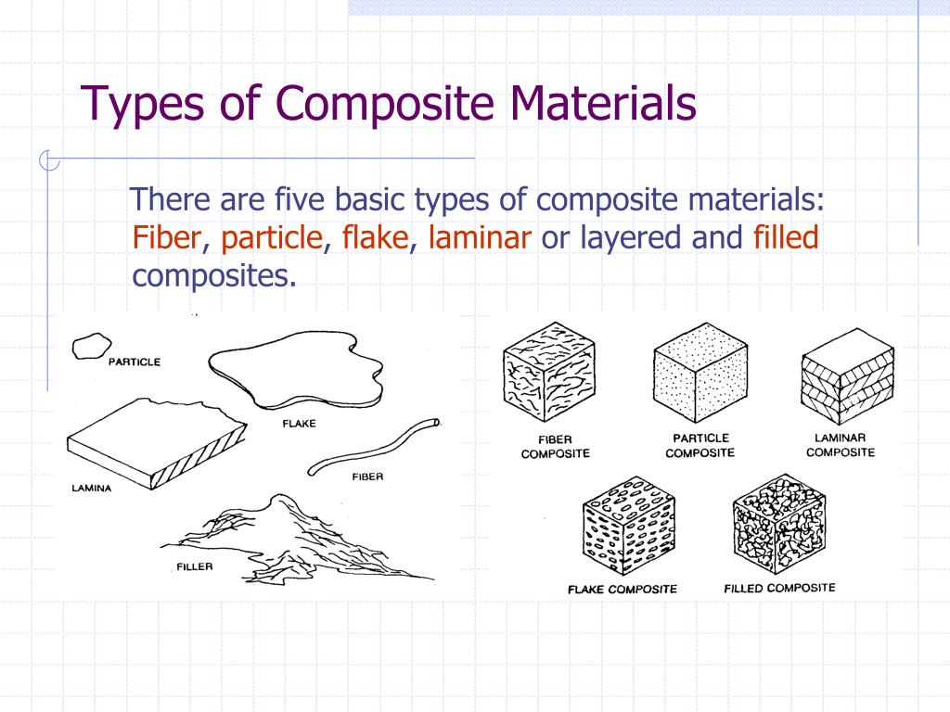

2.2 Modern Development

The true revolution began in the 20th century:

- 1930s: The development of fiberglass (Glass Fiber Reinforced Polymer, GFRP) by Owens-Corning marked the beginning of modern high-performance composites, initially used for insulation.
- World War II: Fiberglass saw widespread application in radar domes and aircraft components due to its lightweight nature and radar transparency.
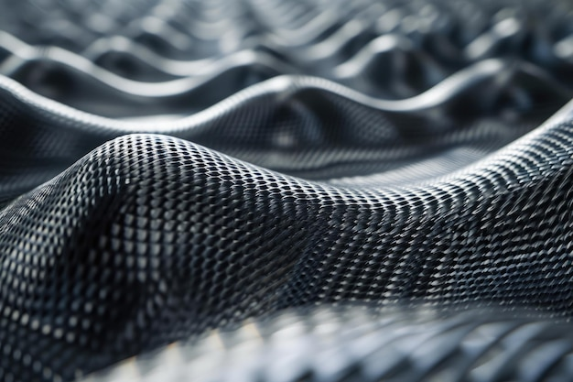
- 1960s: The invention and commercialization of Carbon Fiber Reinforced Polymers (CFRP) and Aramid Fibers (Kevlar) provided materials with unprecedented specific strength and stiffness, driving applications in aerospace and high-performance sports.

3. Working Principle

The fundamental working principle of composite materials relies on the efficient transfer of stress from the matrix to the high-strength reinforcement phase.
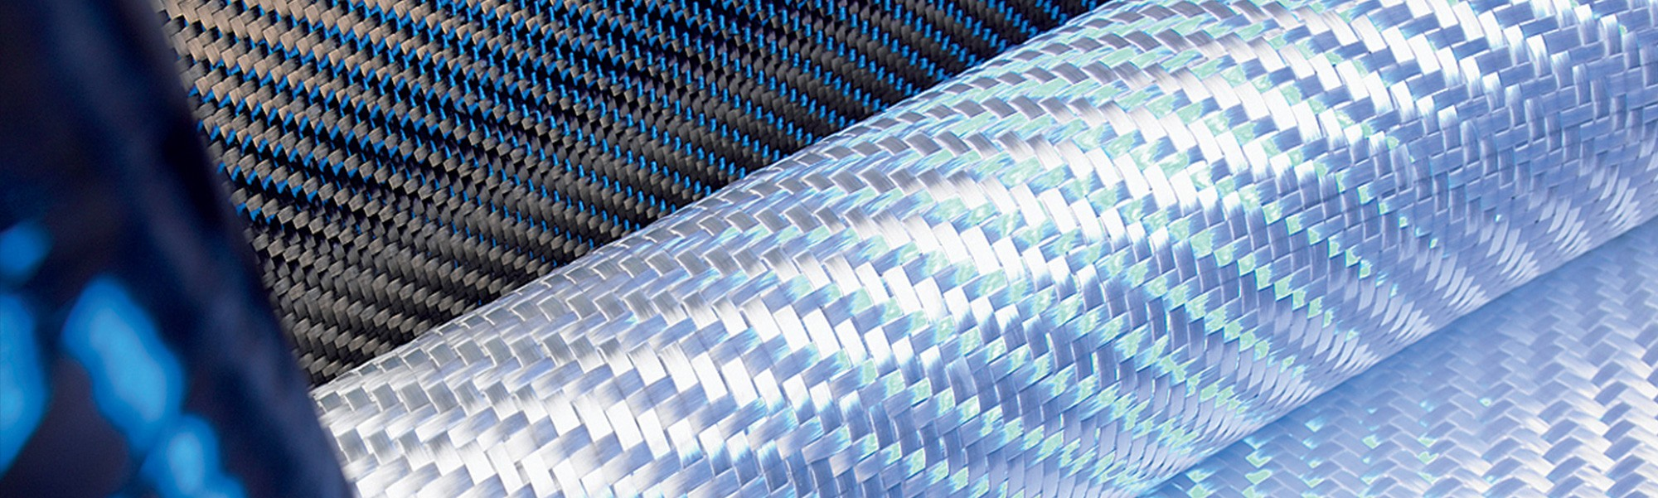

3.1 Load Transfer Mechanism

When an external load is applied to the composite structure:

1. The relatively ductile matrix absorbs the initial stress and distributes it uniformly throughout the material.
2. The stress is then efficiently transferred across the interface (interphase) to the stiff, strong reinforcement fibers.
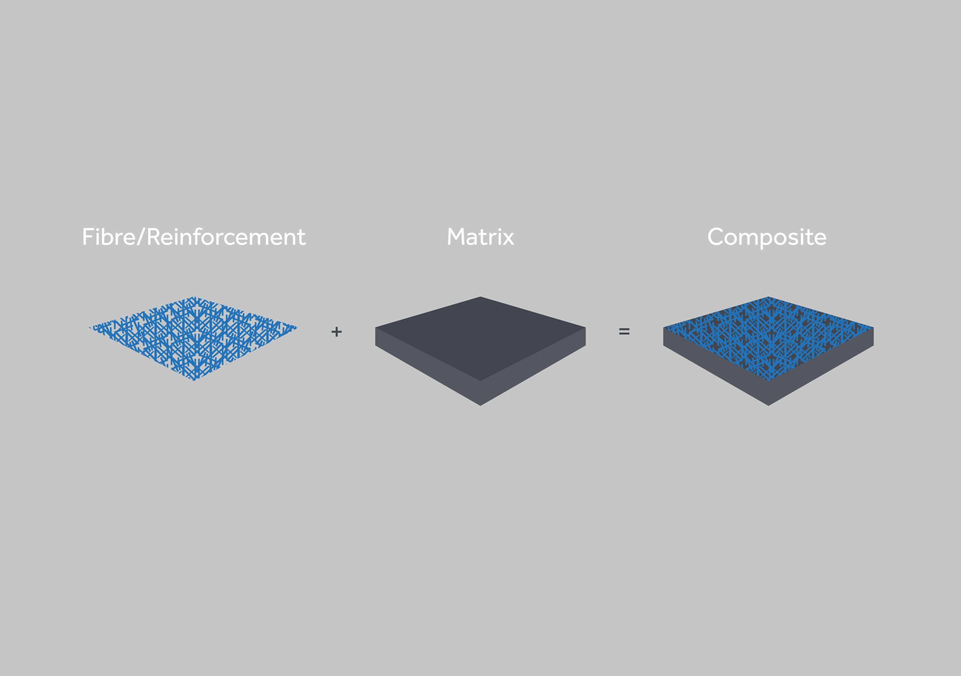
3. The fibers, oriented strategically, bear the majority of the applied load, preventing catastrophic failure and minimizing deformation.

3.2 Rule of Mixtures

The mechanical properties of a composite are often predicted using the Rule of Mixtures, which states that the property (e.g., modulus of elasticity, $E_c$) is a weighted average of the properties of the constituent materials, based on their volume fractions ($V_f$ and $V_m$):

$$E_c = E_f V_f + E_m V_m$$

This principle highlights how the overall performance is directly dependent on the volume fraction and alignment of the reinforcement.

4. Methodology

The methodology for this micro project involved a systematic

